**Samraksh Emote .NET Application Development Tutorial**

Author: Mukundan Sridharan and Nived Sivadas

|  |  |
| --- | --- |
| Revision | Revision Date |
| 1.2 | Jan 26, 2012 |
| 1.3 | Feb 22, 2012 |
| 1.4 | Nov 21,2013 |

**1.0 Emote NETMF Porting Kit and CLR Development Environment Setup:**

**1.1 Software installation**

* Install Visual Studio Express 2013 for Windows Desktop

<http://www.visualstudio.com/en-us/downloads>

Note: Make sure you download “for Windows Desktop” and not just “for Windows” as that is for Windows 8.

* Install NETMF 4.3 SDK (RTM), available at ,

<http://netmf.codeplex.com/releases/view/81000>

* Install the NETMF 4.3 Porting kit (RTM), available at,

<http://netmf.codeplex.com/releases/view/81000>

**Note: It is customary to install porting kit under C:\MicroFrameworkPK_v4_0. This is not necessary through,**

* Install OpenOCD dev, download 32-bit or 64-bit depending on your system, http://www.freddiechopin.info/index.php/en/download/category/10-openocd-dev
* Install usb drivers for Olimex JTAG Adapter drivers. (This depends on the adapter you use, but usually the below driver works)
  + Get the OpenOCD 0.4.0 driver for Olimex ARM-USB-Tiny-H from the page <http://www.olimex.com/dev/arm-usb-tiny-h.html>, look under 'Software'
  + Direct link to driver, http://www.olimex.com/dev/soft/arm/JTAG/DRIVERS%20(libusb-1.2.2.0,%20CDM20808).zip
  + Unzip the files in drivers directory, plugin the dev-board, go to control panel,

device manager, update driver and select driver directory

* Get C++ toolchain from Code sourcery for ARM EABI for Windows, from Samrkash staff

- **Note:** The toolchain directly down load from codesourcery does not work. (http://www.codesourcery.com/sgpp/lite/arm/portal/release1802)

* Download Samraksh NETMF Porting kit from Samraksh GitHub or get a copy from Samraksh Support Team (This is not opensource)
  + GitHub at (Get link from Samraksh Support Team)
  + Copy the Samraksh porting kit source tree on top of the Microsoft porting it source tree.

**1.2 Setuping up the Environment and Compiling**

* Open CMD Prompt
* Go to folder c:\MicroFramework.. or which ever driver you have installed the porting kit code downloaded.
* Set the environment using the command
  + setenv_gcc.cmd c:\CodeSourcery
    - where CodeSourcery is the folder where you downloaded the ARM compilers
  + **Note**: If you use Eclipse you should start Eclipse from command line now, after you setup the environment, so that Eclipse can correctly find the compliers.
* Compile the CLR
  + Go to folder C:\MicroFrameworkPK_v4_0\Solutions\STM32F10x\TinyCLR and
  + run 'msbuild /t:clean tinyclr.proj' to clean the source.
  + run 'msbuild /t:build tinyclr.proj' to build the source.

**1.3. Using Eclipse for Devlopment**

This section is not a must. You can use any editor to do your development and use command line to compile. But it is nice to get Eclipse working.

A good tutorial is available at <http://msmicroframework.blogspot.com/2009/02/configuring-eclipse-openocd-gcc-to.html>, just follow that. At this point you are already done with Codesourcery setup, so proceed directly to Zylin Embedded CDT setup.

**Note:** Zylin CDT for Eclipse has moved. It is now available at: http://opensource.zylin.com/embeddedcdt.html

The Eclipse update site is at http://opensource.zylin.com/zylincdt

**1.4 Other useful references:**

1. Basic Interop tutorial: <http://informatix.miloush.net/microframework/Tutorials/Interop.aspx>
2. Eclipse NETMF tutorial: <http://msmicroframework.blogspot.com/2009/02/configuring-eclipse-openocd-gcc-to.html>
3. Beginners Guide to C# and NETMF from GHI Electronics: <http://www.ghielectronics.com/downloads/FEZ/Beginners%20guide%20to%20NETMF.pdf>
4. Deploying from command line: http://www.eggheadcafe.com/microsoft/NET-Microframework/35747437/how-to-deploy-to-netmf-device-from-command-line.aspx

**2.0 Downloading Software to Emotes through JTAG**

0. JTAG pin connections:

**JTAG Cable:** On the 20 pin cable there is a 2 rows of 10 pins each. One one side there is a small arrow on one side. That is pin 1. So the pin underneath pin 1 would be pin 11.

**emote JTAG Connector:** The eMote has a 7 pin JTAG connector. The pin next to the symbol J2 on board is pin 1.

**Connections:**

|  |  |
| --- | --- |
| Emote Connector | JTAG Cable |
| 1 (Vcc) | 11 (Vcc) |
| 2 | 2 |
| 3 | 4 |
| 4 | 5 |
| 5 | 3 |
| 6 | 7 |
| 7 (Gnd) | 12 (Gnd) |

The Samraksh eMote JTAG connectors is split into a 6-pin (pins 2-6) and 3-pin (pins 1,7) connectors, which can be connected as shown below in the pictures.

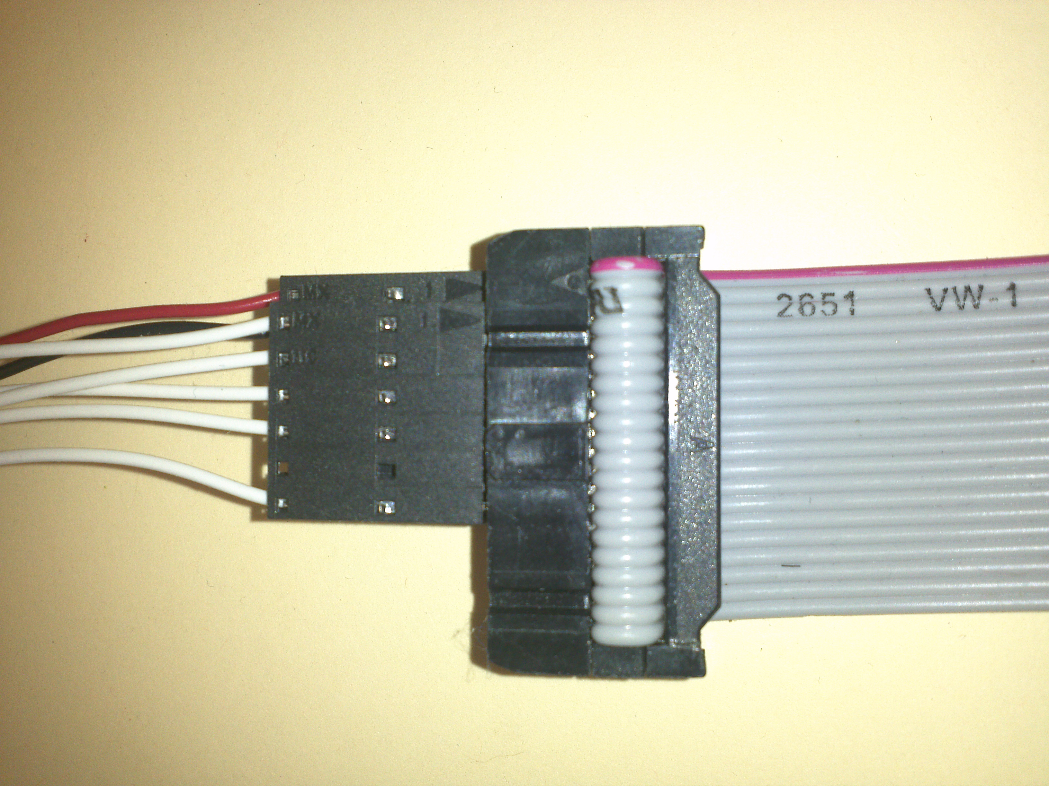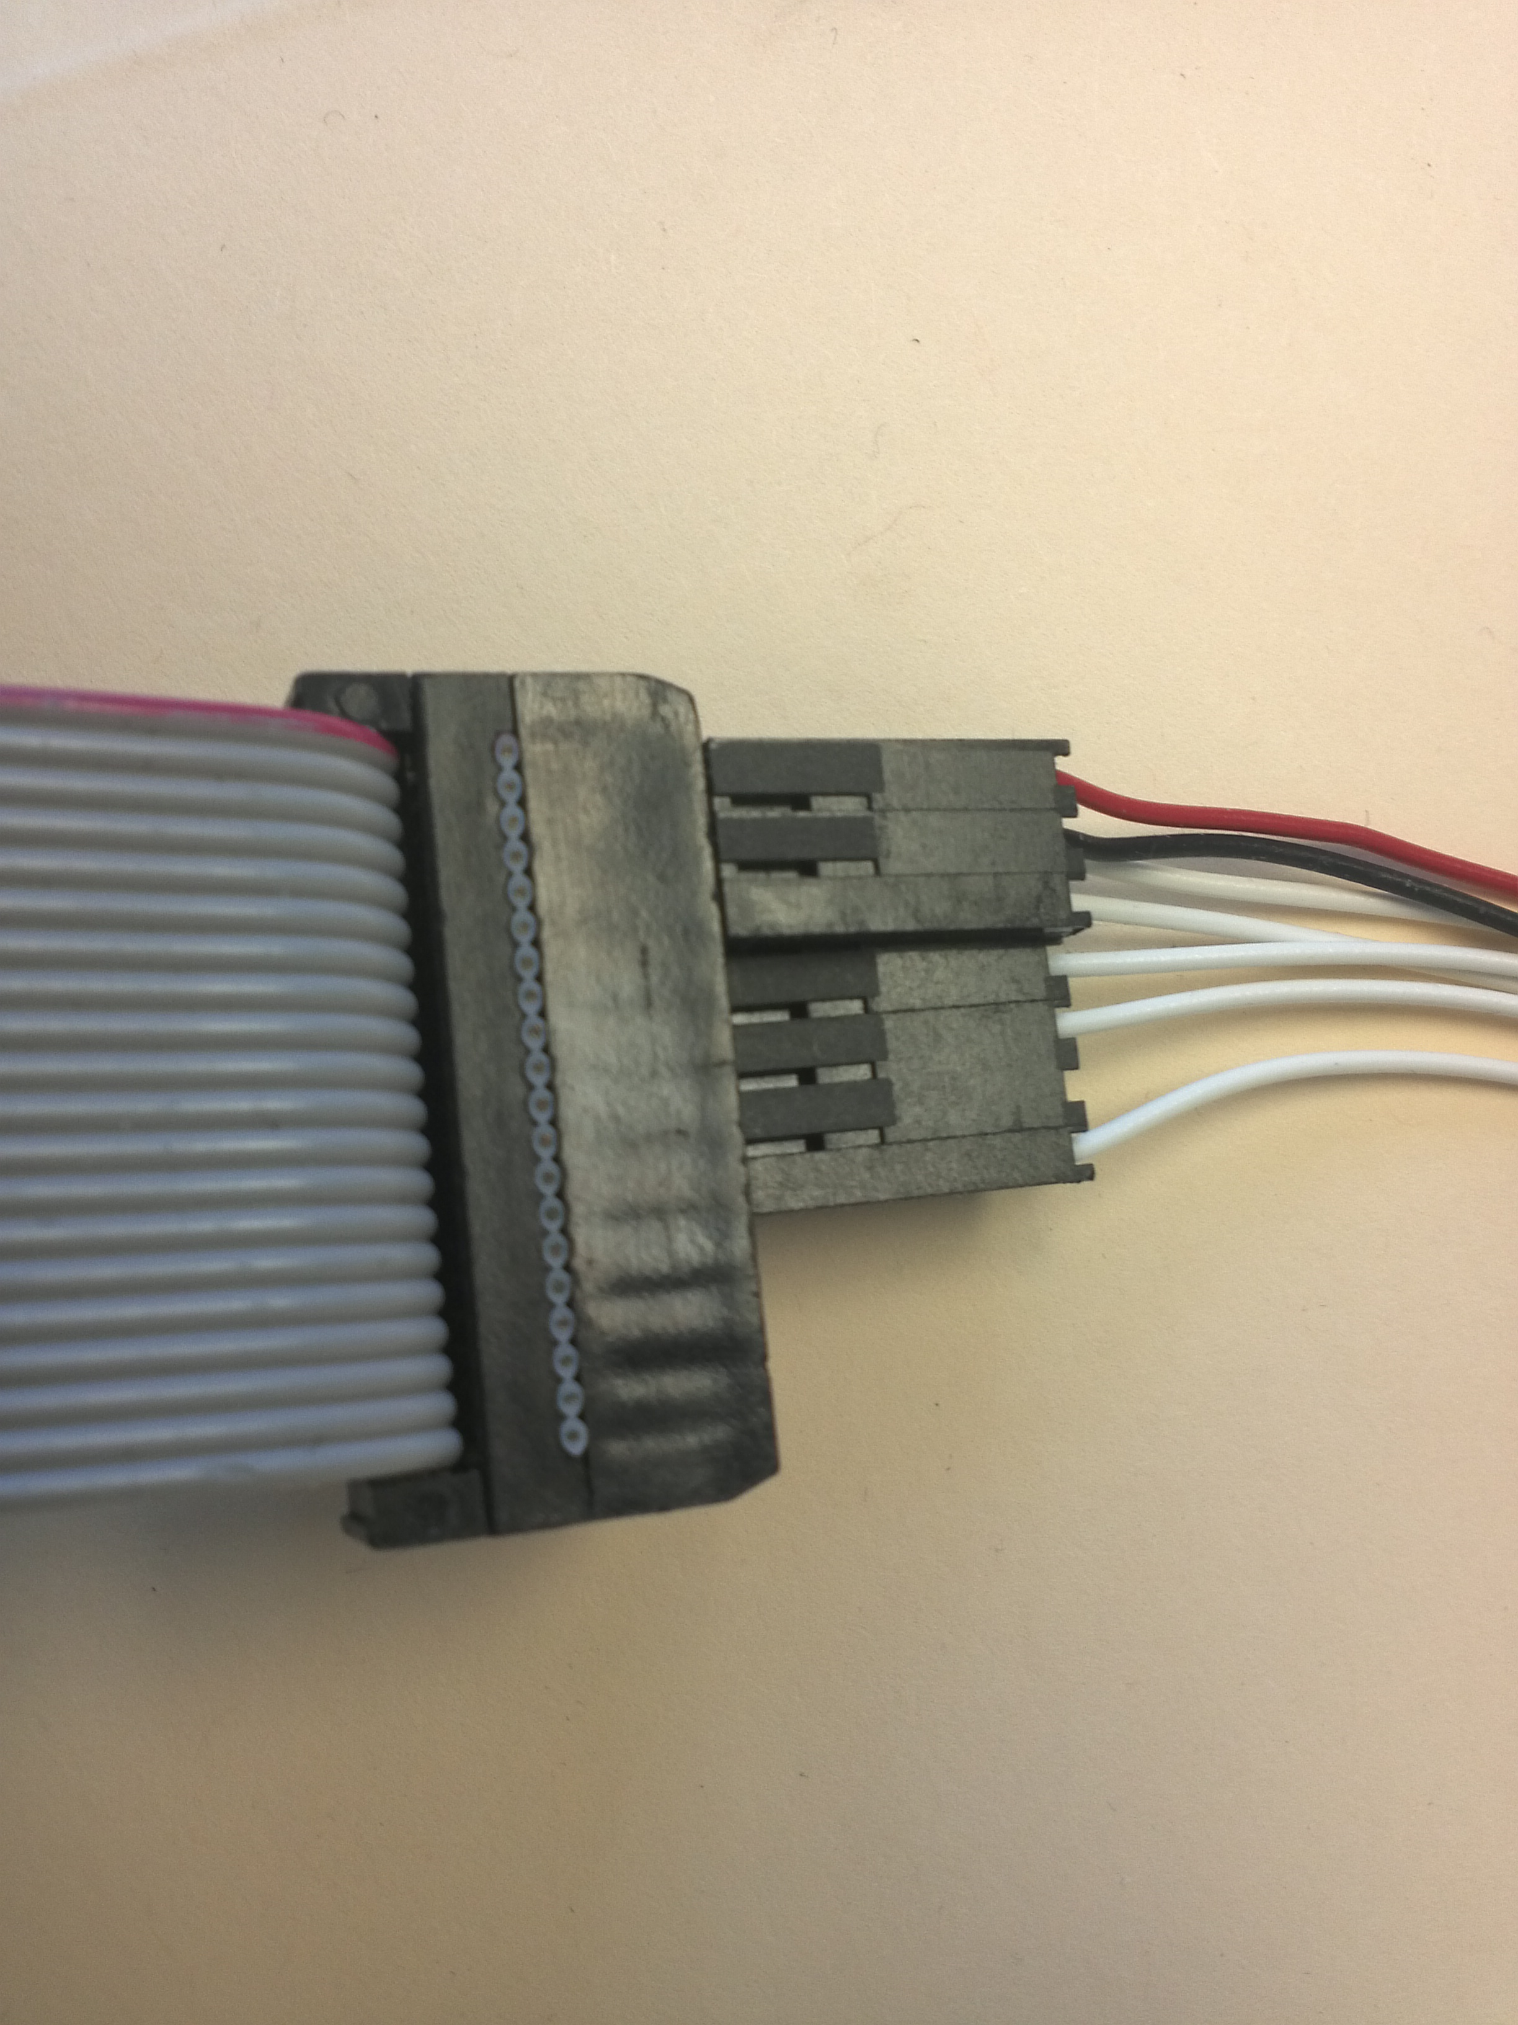

1. Download [OpenOCD](http://www.freddiechopin.info/index.php/en/download/category/4-openocd) version 0.5.0 (32 bit or 64 bit). This software drives the JTAG Programmer and enables you to program the emote. The software comes pre compiled and there is no installation process required.

2. Starting OpenOCD with command.

**openocd-<>.exe –f ..\tcl\interface\olimex-arm-usb-tiny-h.cfg –f ..\tcl\target\stm32xl.cfg**

If the server starts successfully you will get the message shown below.

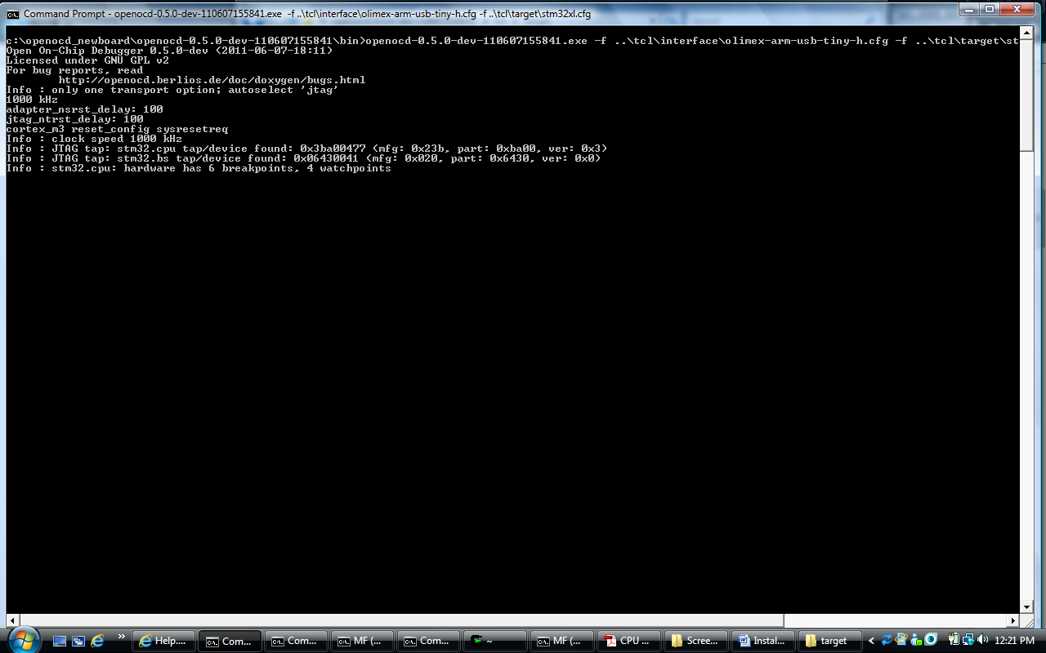

3. Starting the Telnet Service:

**telnet localhost 4444**

This command the telnet interface.

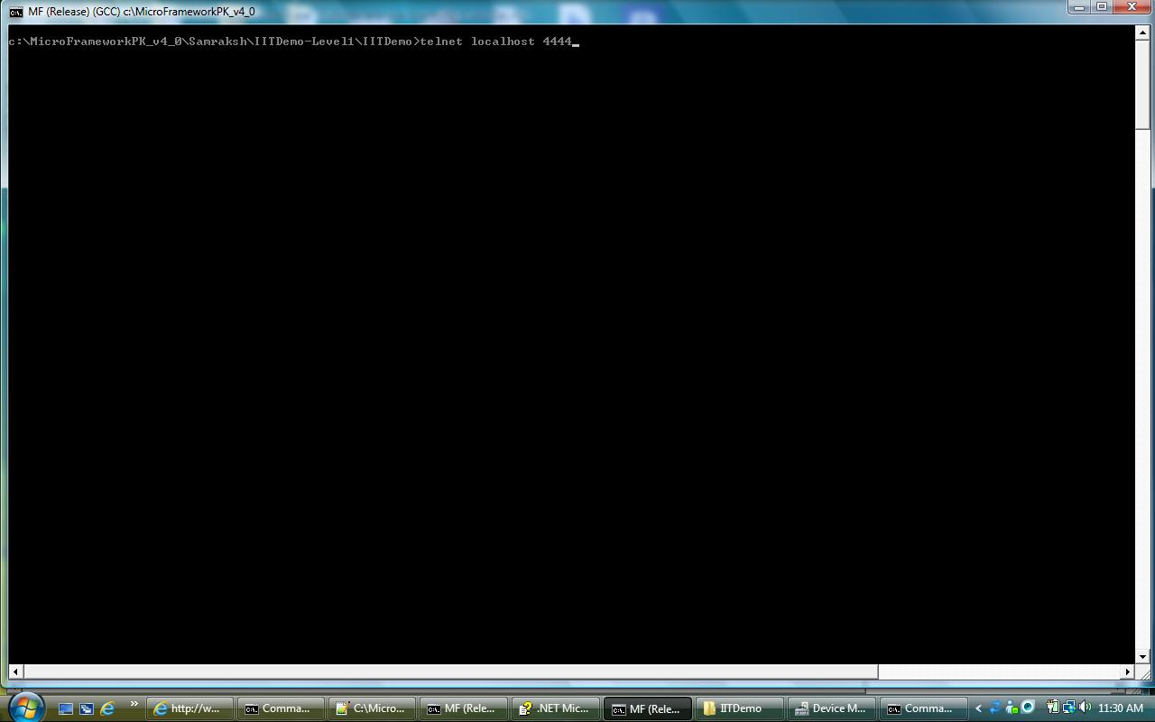

4. Flashing the c# app

**stm32x mass_erase 1**

This command erases bank 1 on the chip

**flash write_image <path>filename.s19**

This command writes the c# app to flash

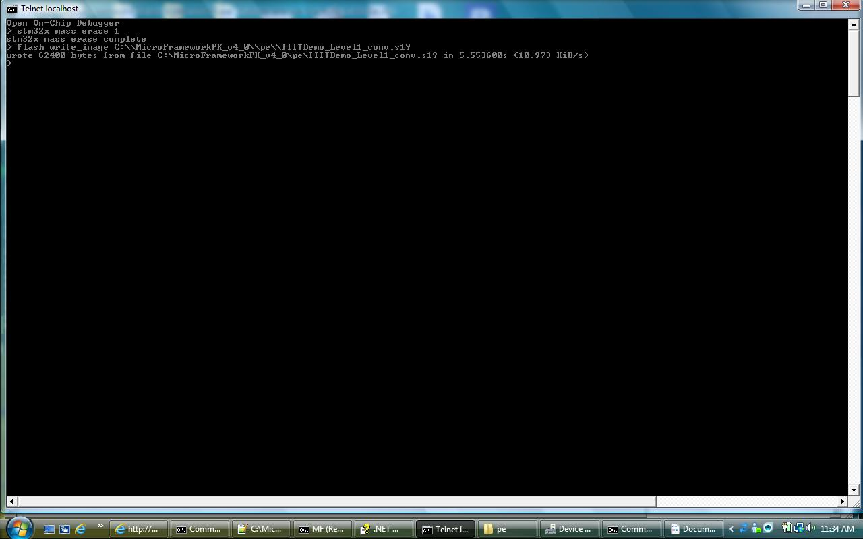

5. Loading Interpreter

**soft_reset_halt**

resets the cpu and halts it.

**stm32x mass_erase 0**

erases bank 0 of the flash

**flash write_bank 0 <tinyclr.bin> 0**

writes the interpreter to the flash, note that the command here is write_bank and not write_image as was the case in during the application flashing

**exit**

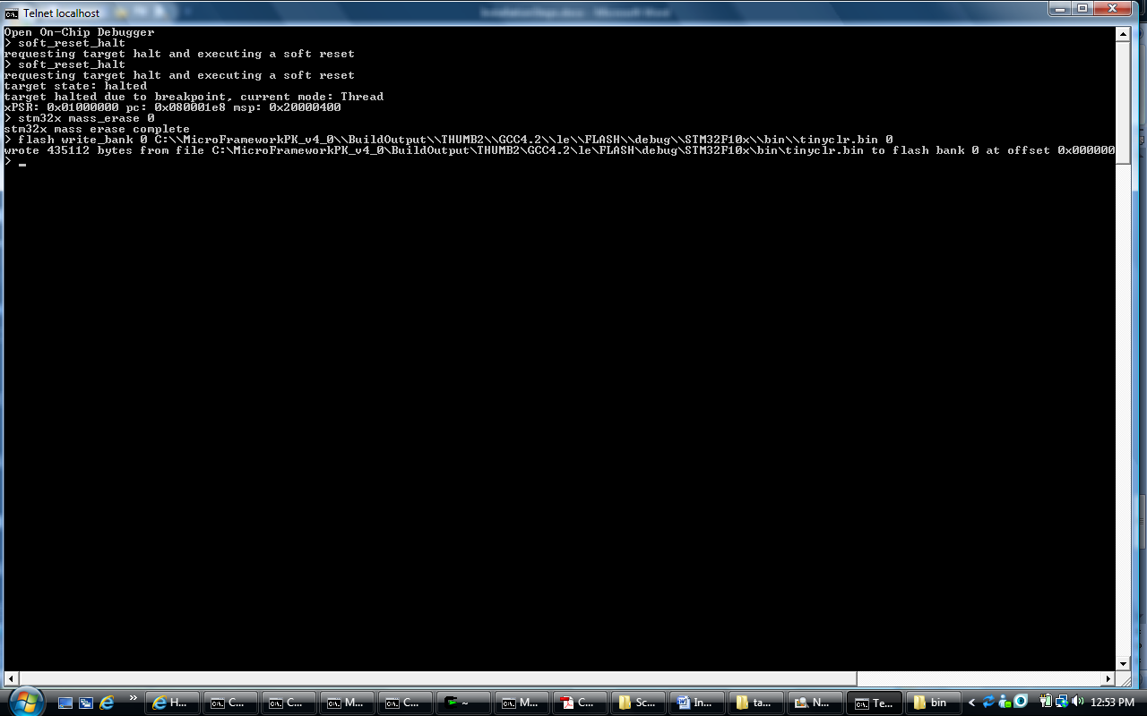

6. Now Power cycle the mote and the application starts running.

**3.0 Building C# Applications**

1. Create a new application in visual studio.

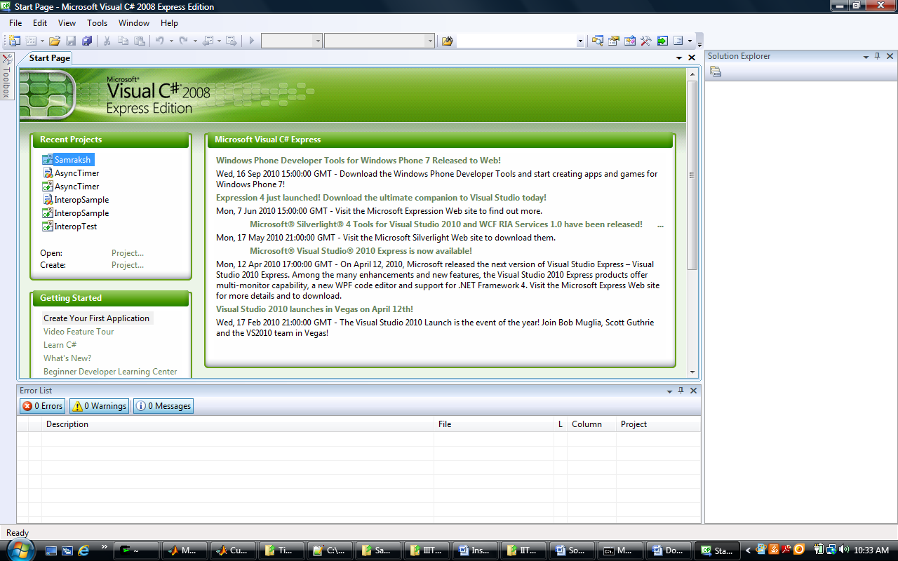

2. The application is a console application

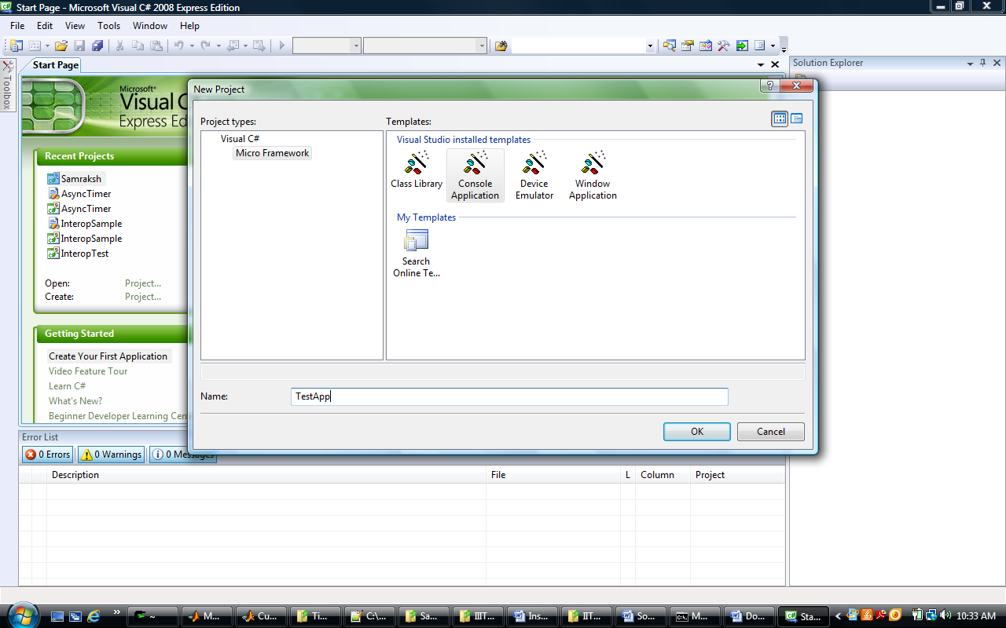

3. This generates a project as shown below.

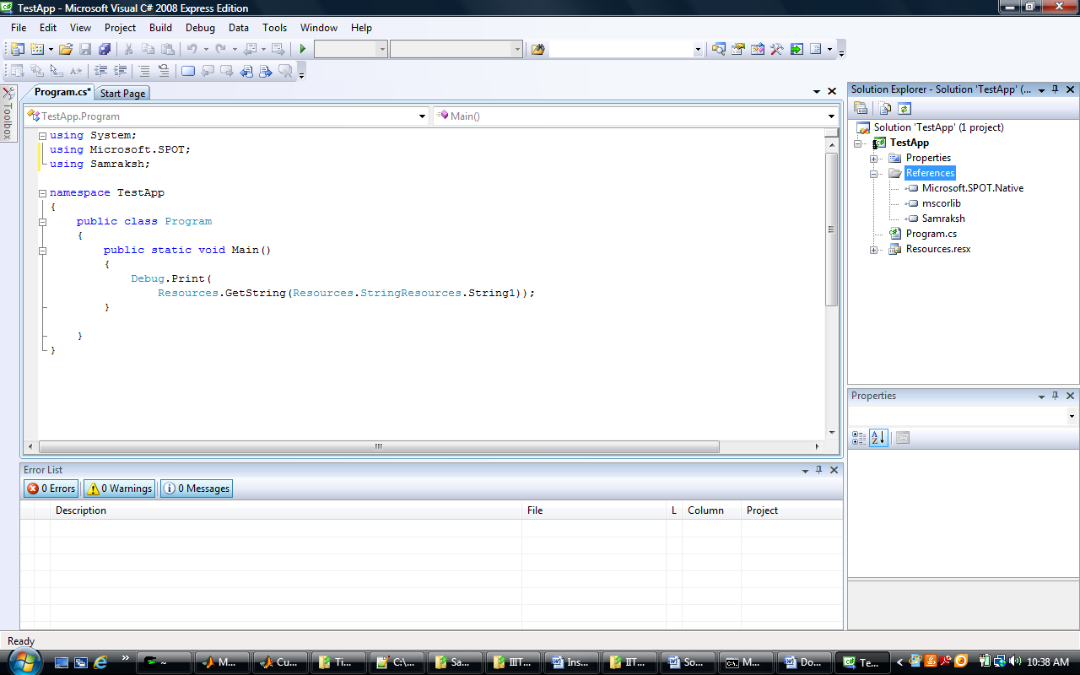

4. Once you have written the application, close visual studio and open the .csproj file corresponding to the application you have created. Replace the highlighted line with the lines shown in the next figure.

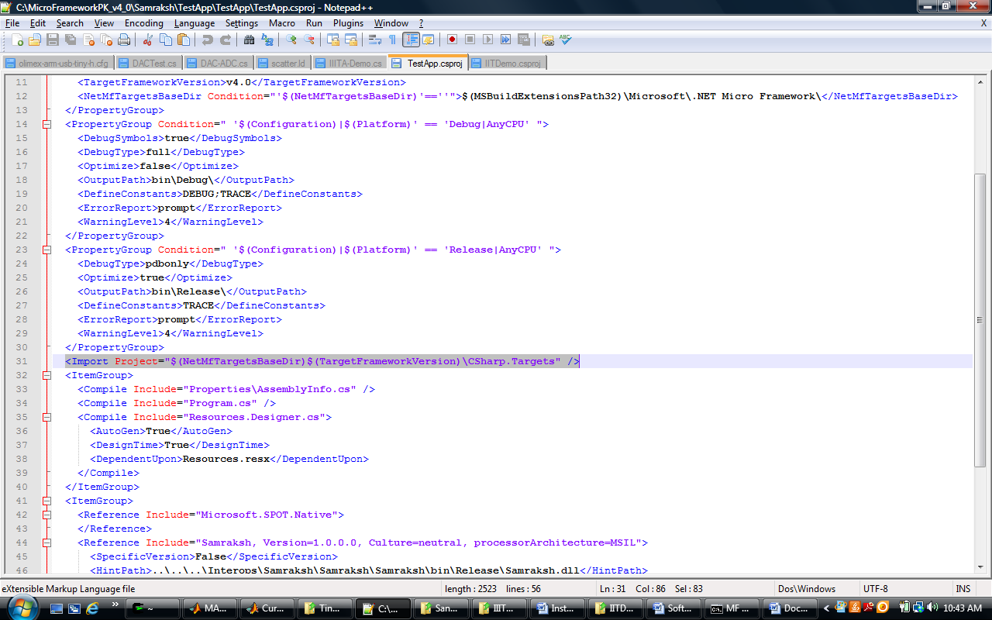

The objective here is to modify the project to create a .dat file which is used as the executable in future steps.

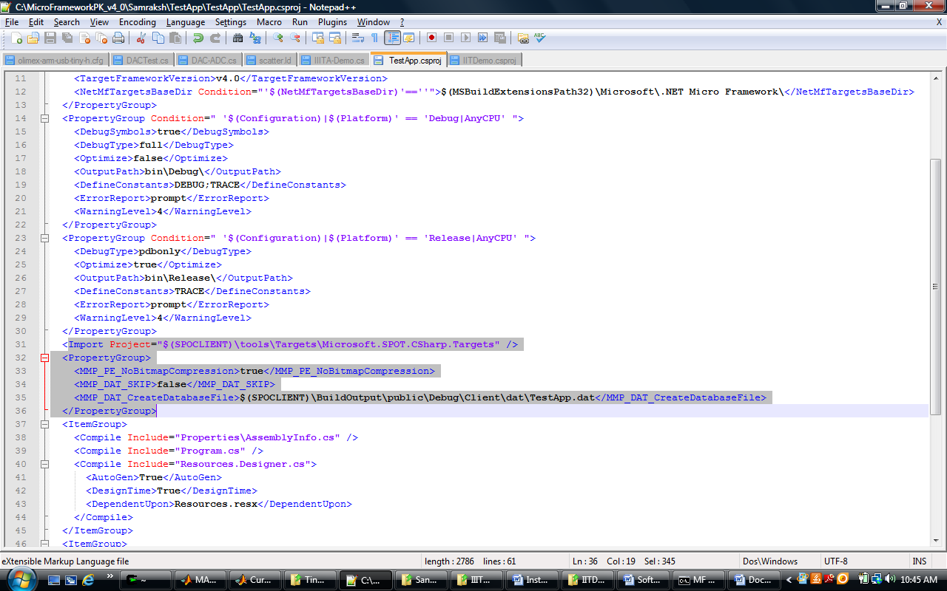

5. Now build the application from the command line using msbuild as shown below.

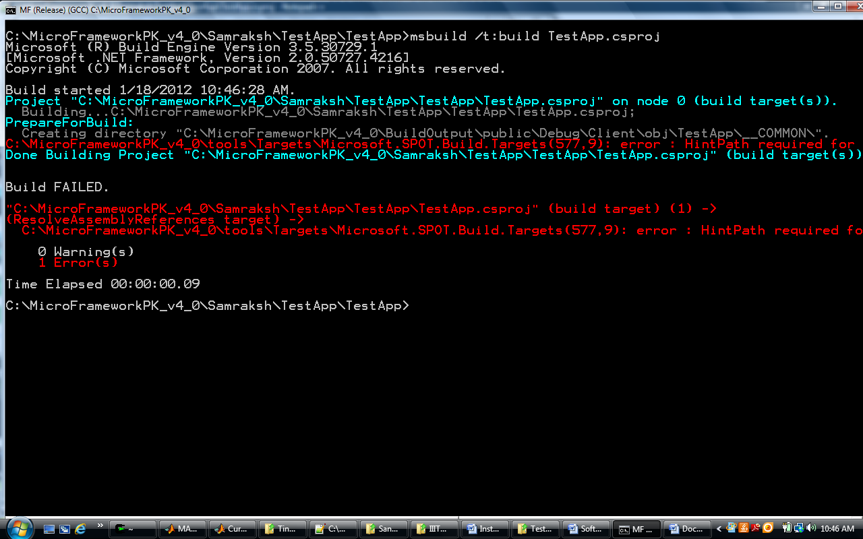

6. Build complains saying the HintPath is required. Open the .csproj file once again and add hint paths for all references including the Samraksh.dll if not already present.

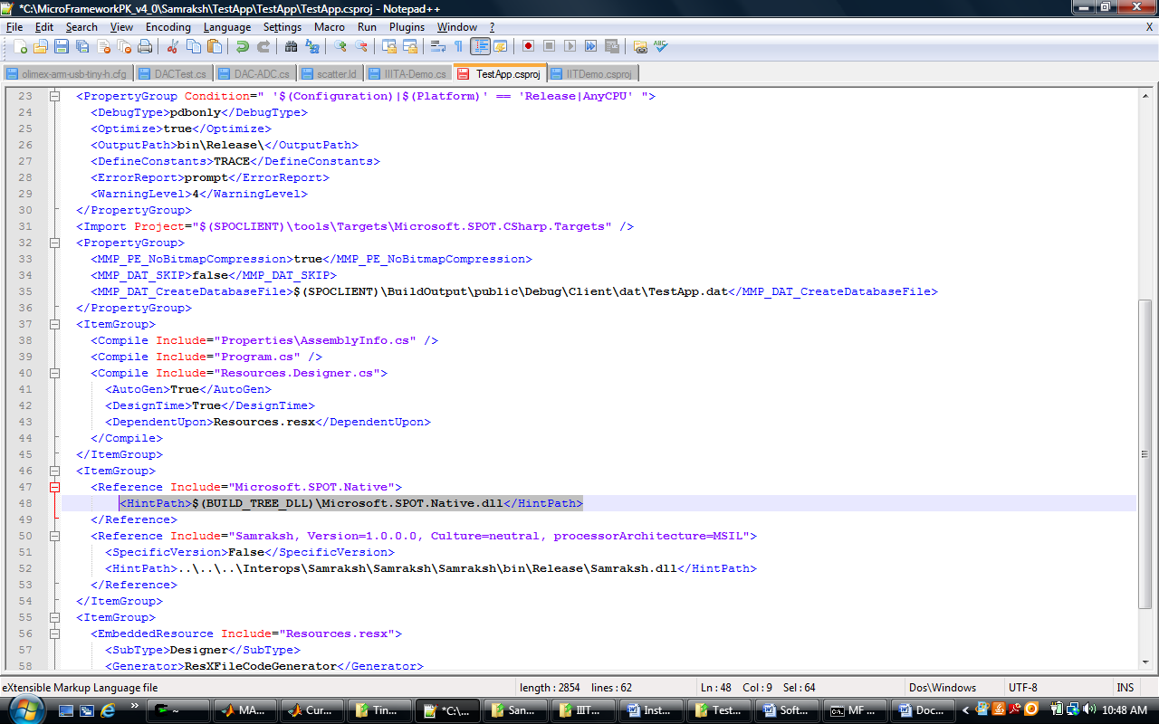

7. Now build the application once again.

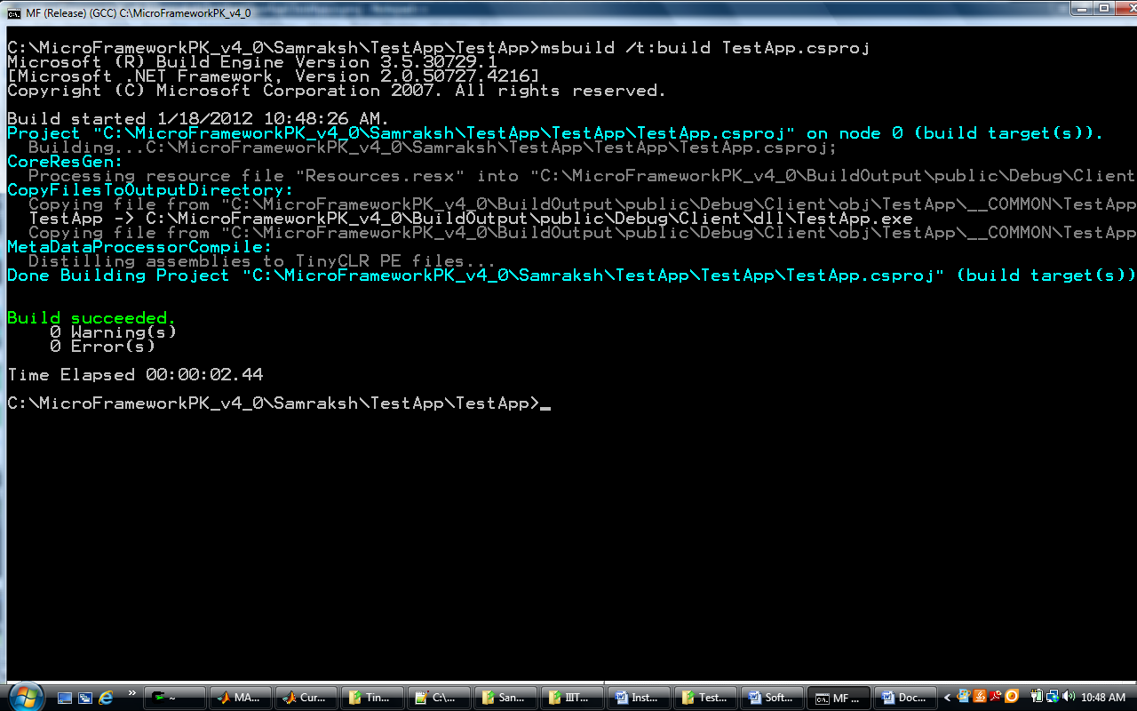

8. If the build succeeds without errors you will find the dat file in the folder below.

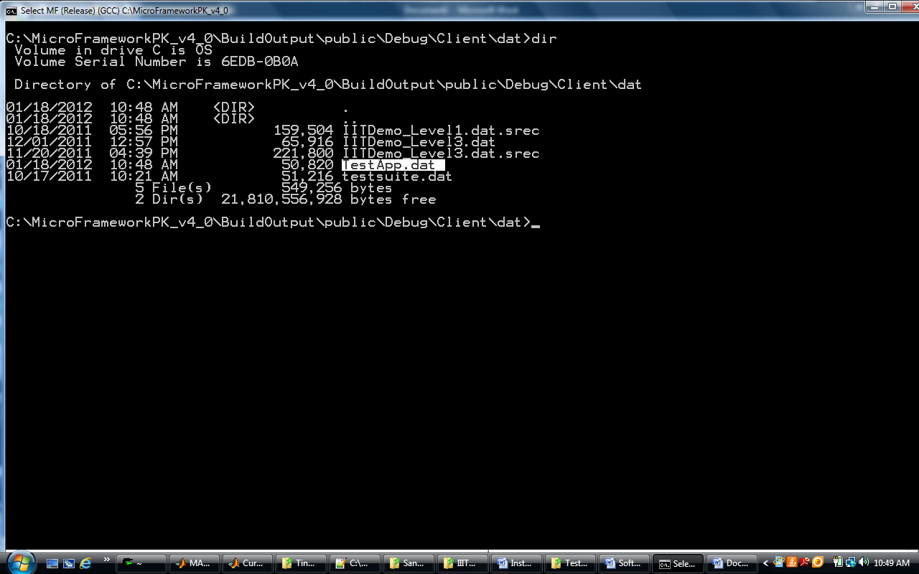

9. The next step is to convert the dat file to s19 which can be used to flash the mote. The command for this is

binToSrec.exe –b 8080000 –i TestApp.dat –o TestApp.s19

8080000 represents the starting address of the C# binary

TestApp.dat represents the input file and

TestApp.s19 represents the output file

(If you do not have micro framework installed, binToSrec.exe is attached with this packet)

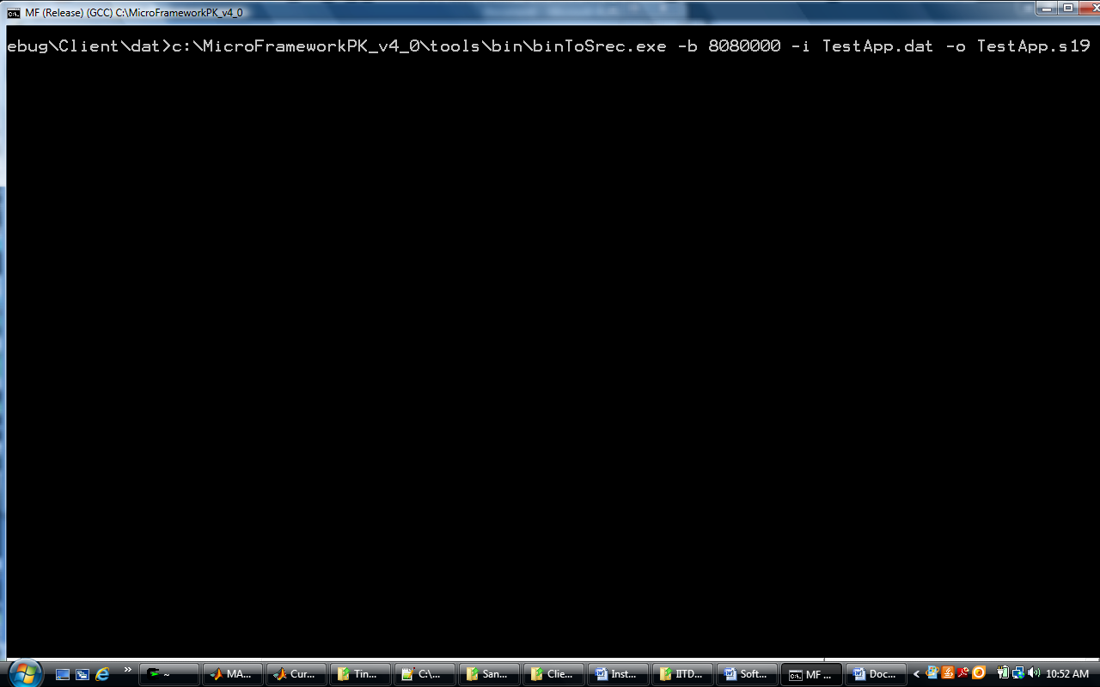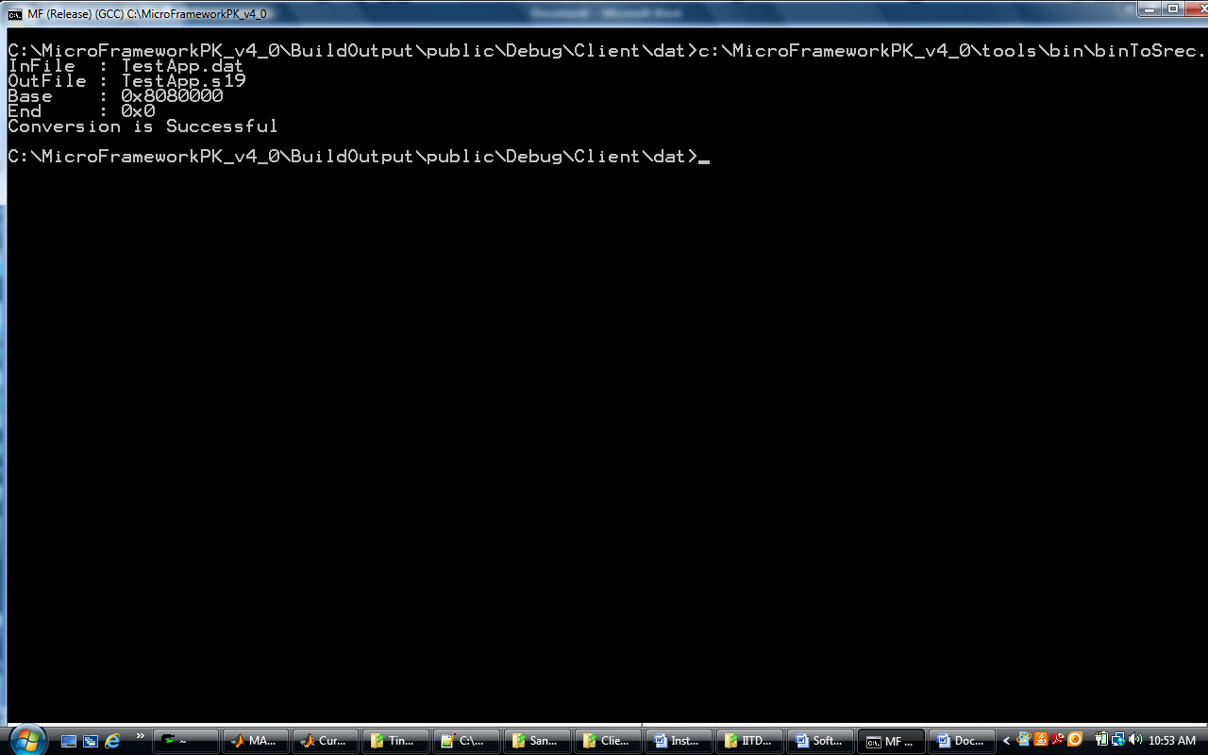

10. The s19 file generated by step 9 is not the right format and needs to be converted through the command below.

Arm-none-eabi-objcopy.exe TestApp.s19 TestApp_Conv.s19

(If you do not have codesourcery lite installed, you can either obtain it online or I am attaching arm-none-eabi-objcopy.exe with this packet)

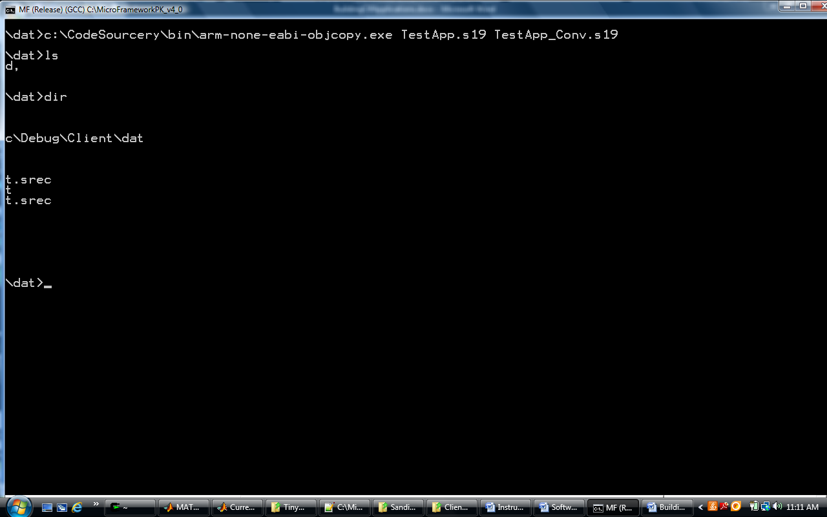

11. The result of this step can now be loaded on to the mote. The instructions on how this is done is available in the document SoftwareDownloadToNode.docx.